**Calculating Family Expenses Using Servicenow**

**Team ID: NM2025TMID17163**

**Team Members : 4**

**Team Leader : NAVIYA . P**

**Team Member 1 : NANDHINI . K**

**Team Member 2 : JENCY . M**

**Team Member 3 : DHANALAKSHMI . D**

**Problem Statement :**

Managing family expenses manually often leads to errors, difficulty in tracking spending habits, and lack of consolidated reporting. There is a need for a system that records daily expenses, links them to family members, and generates insights.

**Objectives :**

* **To create a ServiceNow application for managing family expenses.**
* **To design custom tables for Family Members and Daily Expenses.**
* **To build relationships so each expense can be mapped to a family member.**
* **To configure related lists for better visibility of data.**
* **To create business rules for automation and va**

**Skills Required:**

* **ServiceNow Instance Setup**
* **Update Sets Management**
* **Table Creation & Relationships**
* **Business Rules Configuration**
* **Related List Setup**
* **Data Validation & Reporting**

**TASK INITIATION**

### Milestone 1: Creation of New Update Set

1. Go to All >> In the filter search for Local Update set > click on New.

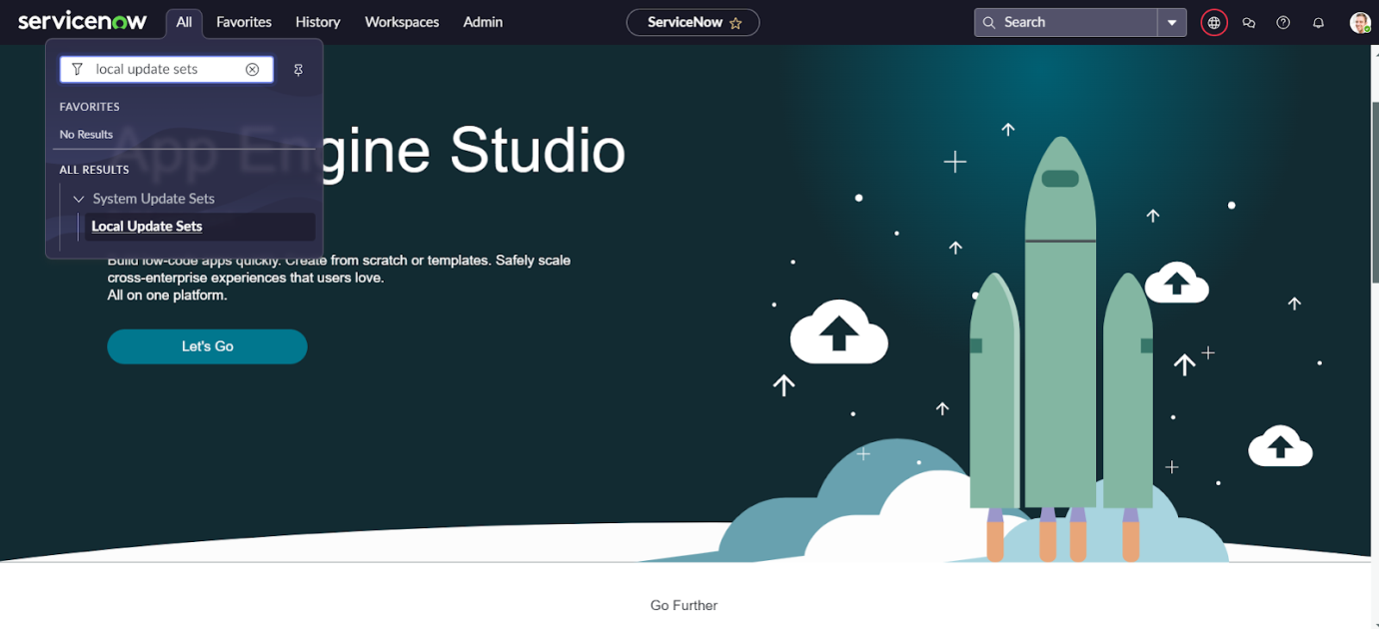

1. Enter the Details as:

Name : Family Expenses

3. Then click on Submit and Make current.

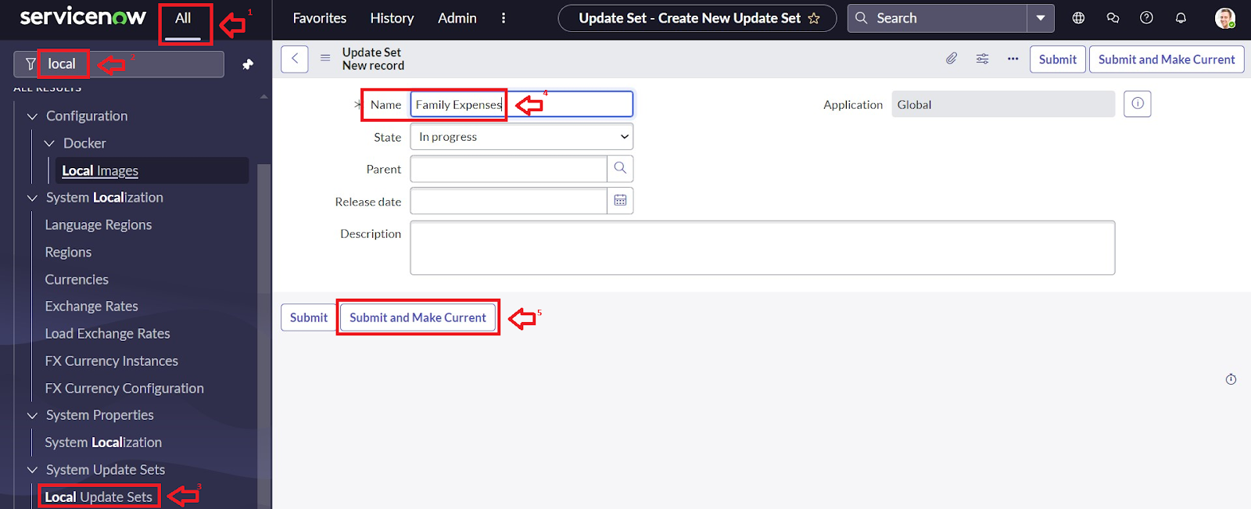

### Milestone 2: Creation of New Update Set

1. Go to All >> In the filter search for Local Update set > click on New.



1. Enter the Details as:

Name : Family Expenses

1. Then click on Submit and Make current.



### Milestone 3 : Creation of Family Expenses Table

1. Go to All > In the filter search for Tables > click on New.
2. Enter the Details:

Label : Family Expenses

Name : Auto-Populated

New menu name : Family Expenditure

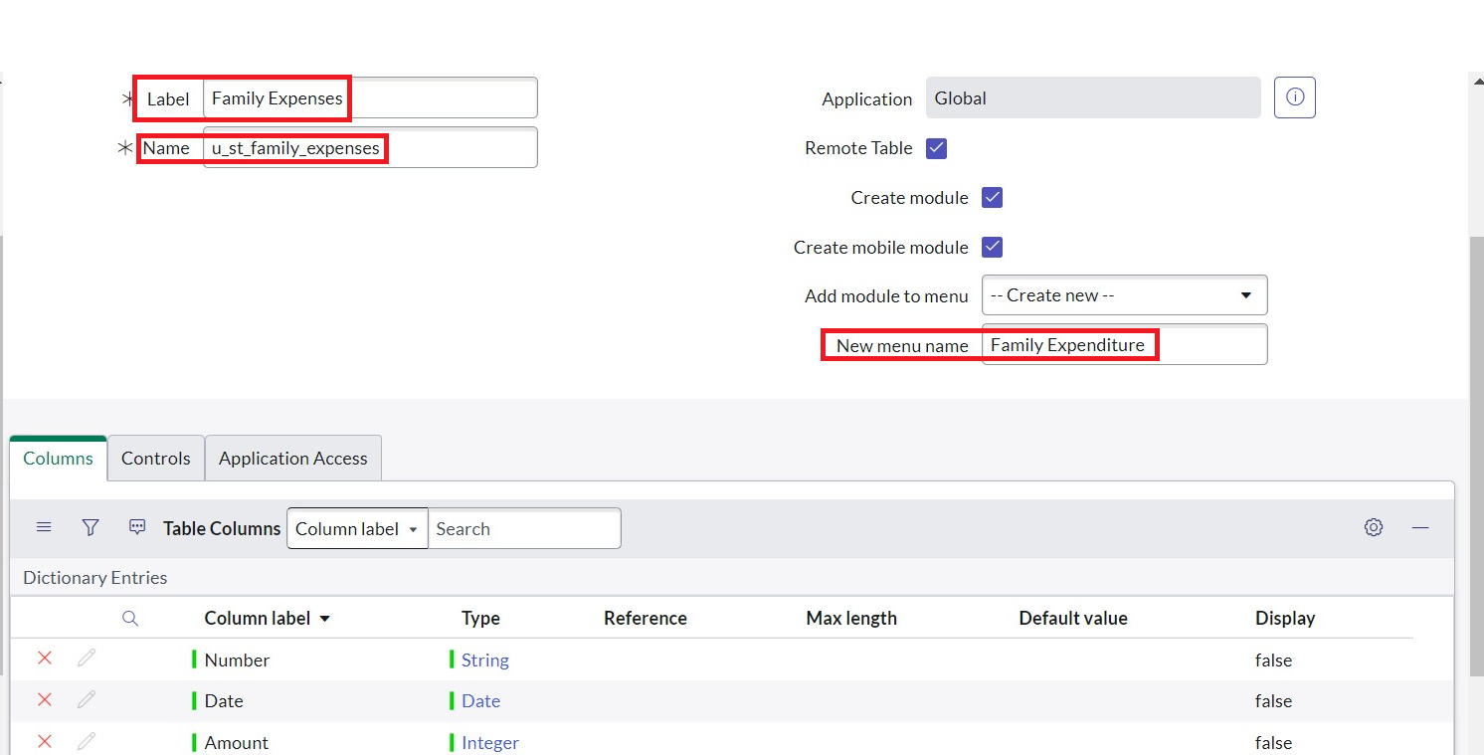

1. Go to the Header and right click there>> click on Save.

### Milestone 4 : Creation Of Columns(Fields)

1. Near Columns Double click near insert a new row.
2. Give the details as:

Column label : Number

Type : String

1. Double click on insert a new row again
2. Give the details as:

Column label : Date

Type : Date

1. Double click on insert a new row again
2. Give the details as:

Column label : Amount

Type : Integer

1. Double click on insert a new row again
2. Give the details as:

Column label : Expense Details

Type : String

Max length : 800

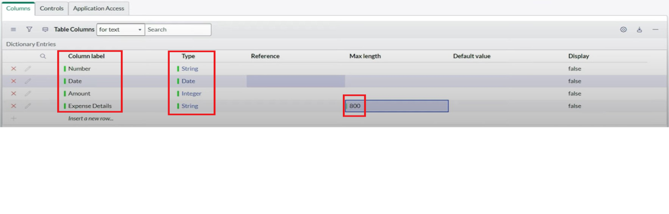

1. Go to the Header and right click there>> click on S

### Milestone 5 : Making Number Field an Auto-Number

1. Double click on the Number Field/Column.
2. Go down and double click on Advanced view
3. In Default Value:

Use dynamic default : check the box

Dynamic default value : Get Next Padded Number

1. Click on Update.
2. 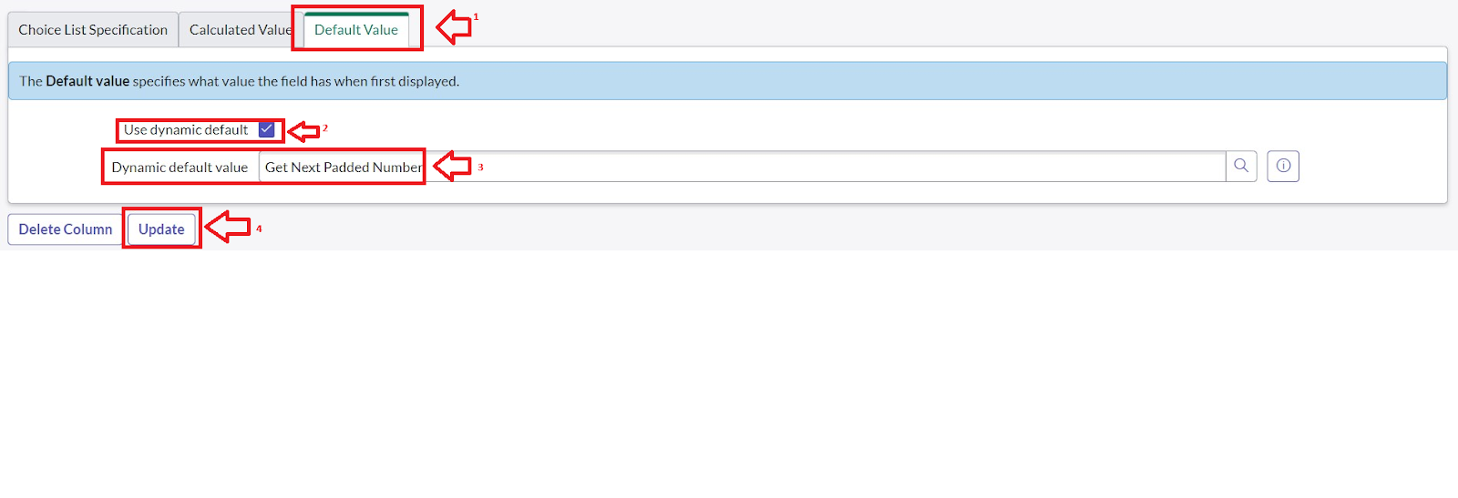
3. Go to All >> In the filter search for Number Maintenance >> select Number Maintenance
4. Click on New.
5. Enter the below Details:

Table : Family Expenses

Prefix : MFE

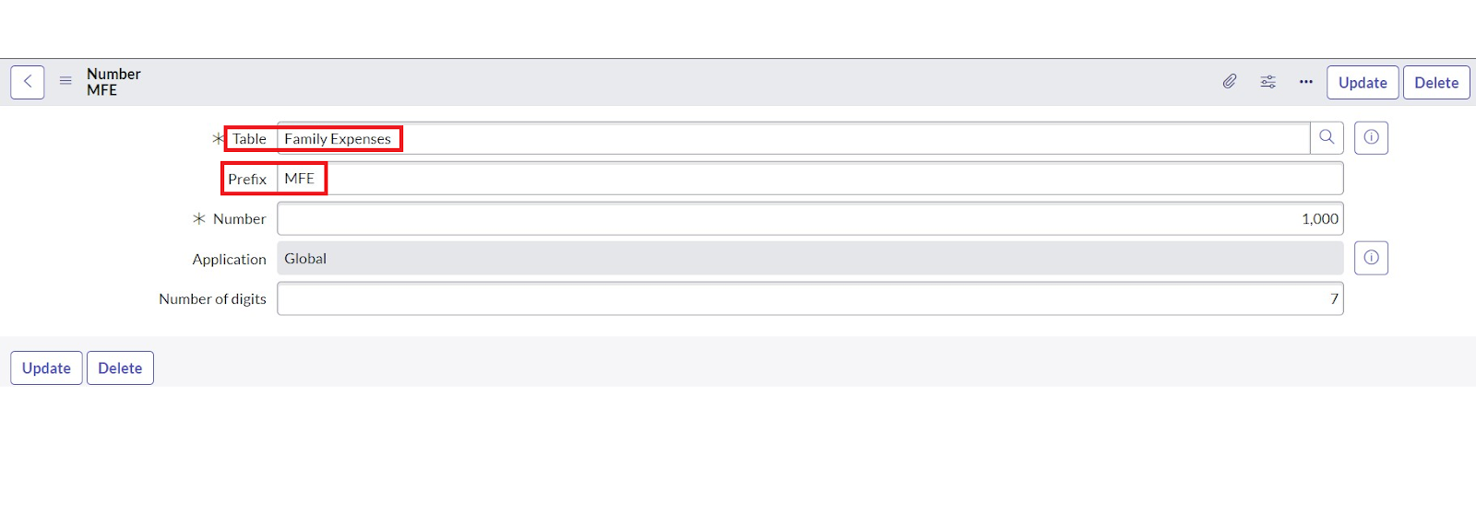

1. Click on Submit.

### Milestone 6 : Configure The Form

1. Go to All >> In the filter search for Family Expenses >> Open Family Expenses
2. Click on New
3. Go to the Header and right click there>> click on Configure >> Select Form Design
4. Customize or Drag Drop the form as per your requirement.

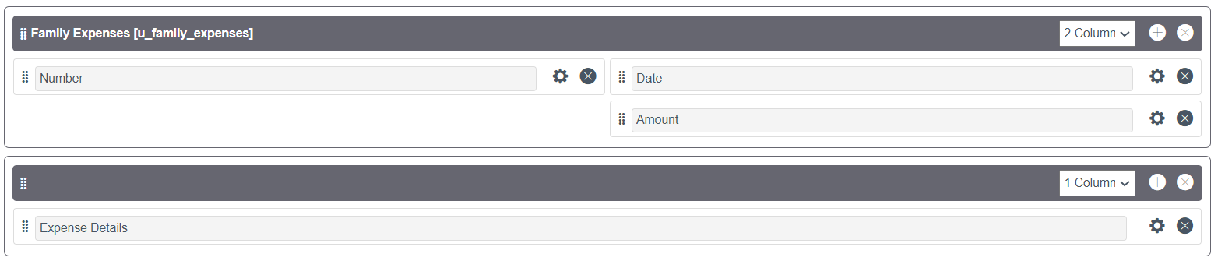

1. Make Number Read-Only Field by clicking on the gear icon and checking Read-Only
2. Make Date, Amount Mandatory Field by clicking on the gear icon and checking Mandatory
3. Click on Save.

### Milestone 7 : Creation Of Daily Expenses Table

1. Go to All > In the filter search for Tables > click on New.
2. Enter the Details:

Label : Daily Expenses

Name : Auto-Populated

Add Module to menu : Family Expenditure

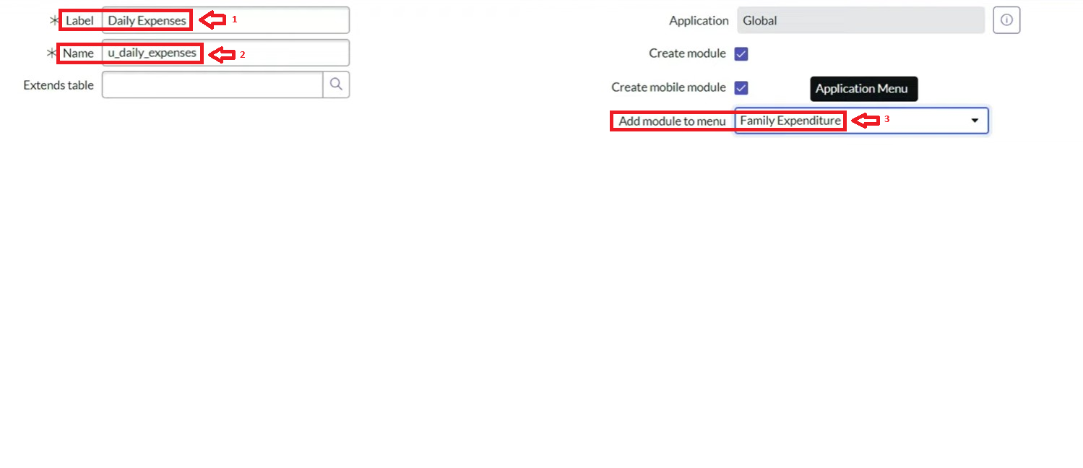

1. Go to the Header and right click there>> click on Save.

### Milestone 8 : Creation Of Columns(Fields)

1. Near Columns Double click near insert a new row.
2. Give the details as:

Column label : Number

Type : String

1. Double click on insert a new row again
2. Give the details as:

Column label : Date

Type : Date

1. Double click on insert a new row again
2. Give the details as:

Column label : Expense

Type : Integer

1. Double click on insert a new row again
2. Give the details as:

Column label : Family Member Name

Type : Reference

Max length : 800

1. Double click on insert a new row again
2. Give the details as:

Column label : Comments

Type : String

Max length : 800

1. Go to the Header and right click there>> click on Sav

### Milestone 9 : Making Number Field an Auto-Number

1. Double click on the Number Field/Column.
2. Go down and double click on Advanced view
3. In Default Value:

Use dynamic default : check the box

Dynamic default value : Get Next Padded Number

1. Click on Update.
2. 
3. Go to All >> In the filter search for Number Maintenance >> select Number Maintenance
4. Click on New.
5. Enter the below Details:

Table : Family Expenses

Prefix : MFE

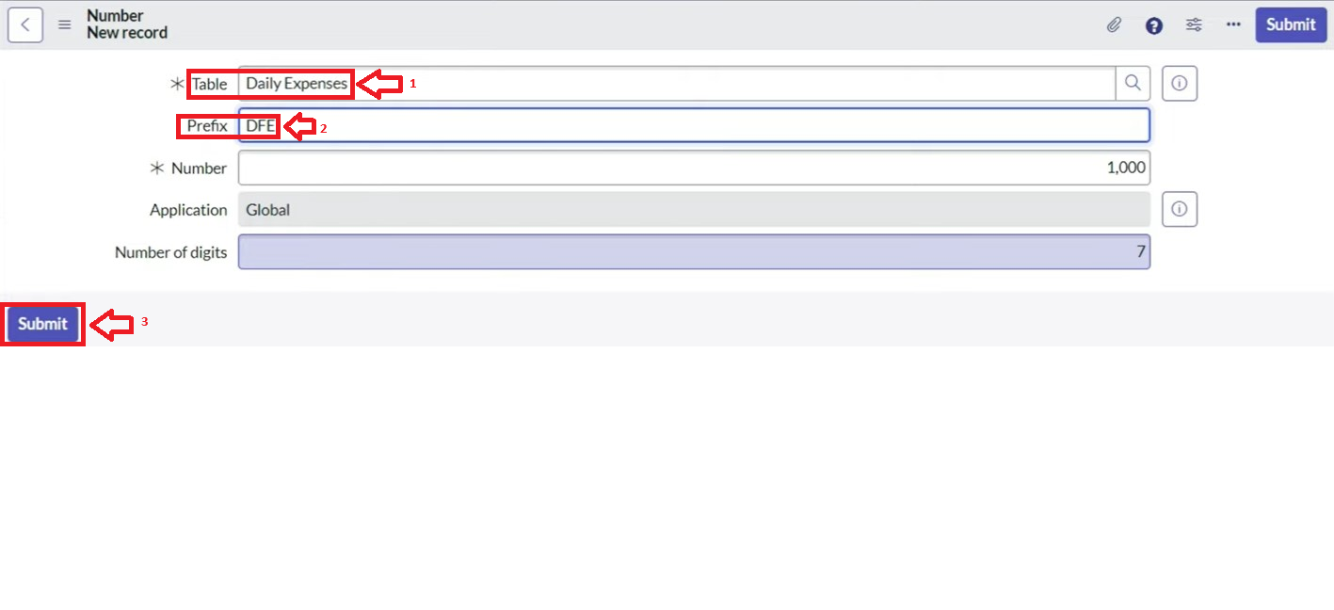

1. Click on Submit.

### Milestone 10 : Configure The Form

1. Go to All >> In the filter search for Daily Expenses >> Open Daily Expenses
2. Click on New
3. Go to the Header and right click there>> click on Configure >> Select Form Design
4. Customize or Drag Drop the form as per your requirement.

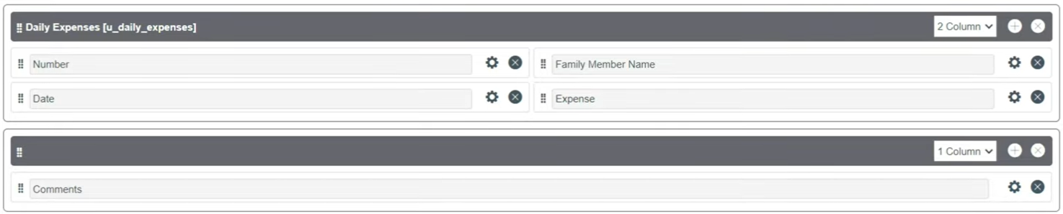

1. Make Number Read-Only Field by clicking on the gear icon and checking Read-Only
2. Make Date, Family Member Name Mandatory Field by clicking on the gear icon and checking Mandatory
3. Click on Save.

### Milestone 11 : Creation of Relationship between Family Expenses and Daily Expenses tables

1. Go to All >> In the filter search for Relationships >> Open Relationships
2. Click on New.
3. Enter the details:

Name : Daily Expenses

Applies to table : Select Family Expenses

Daily Expenses : Select Daily Expenses

1. Click Save.

### Milestone 12 : Configuring Related List on Family Expenses

1. Go to All >> In the filter search for Family Expenses >> Open Family Expenses
2. Click on New
3. Go to the Header and right click there>> click on Configure >> Select Related Lists
4. Add Daily Expenses to the Selected Area.
5. Click on Save

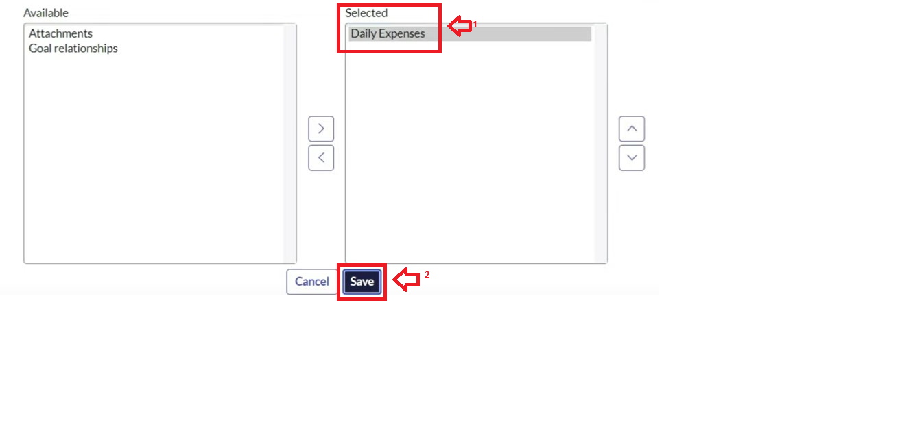

### Milestone 13 : Creation Of Business Rules

1. Go to All >> In the filter search for Business Rules.
2. Under System Definition Select Business Rules then click on New.
3. Enter the Details:

Name : Family Expenses BR

Table : Select Daily Expenses

Check Advanced

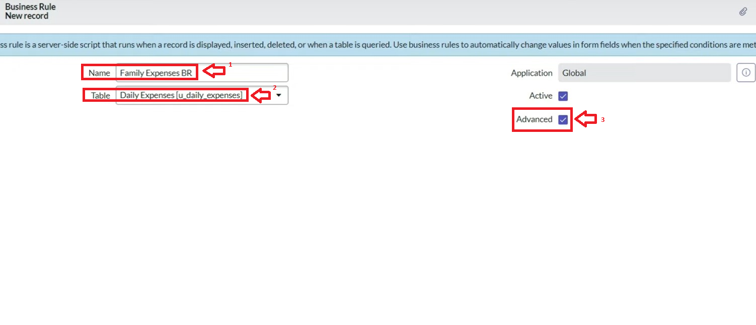

1. In when to run Check Insert and Update

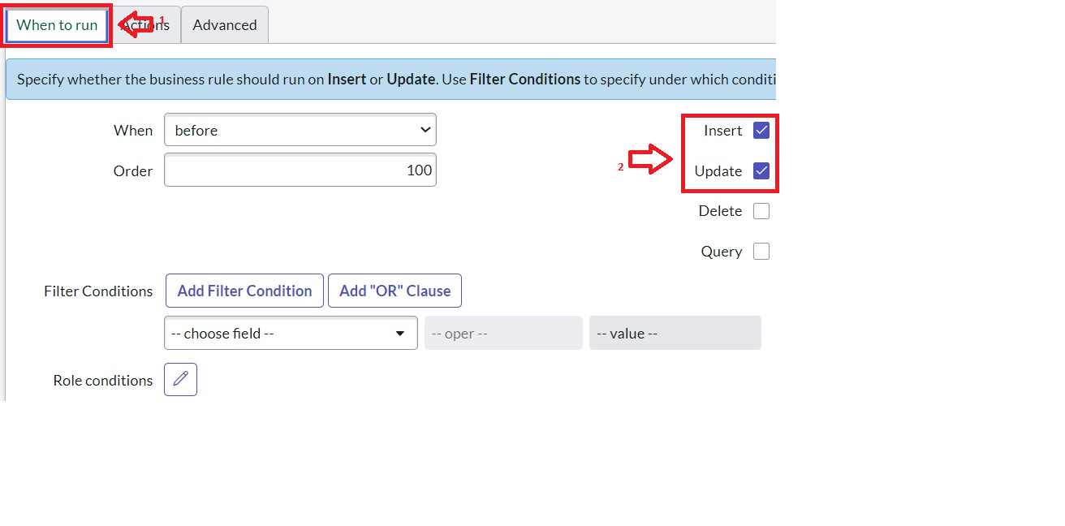

1. In Advance(we write the code): Write the below code >>

(function executeRule(current, previous /*null when async*/) {

var FamilyExpenses = new GlideRecord('u_family_expenses');

FamilyExpenses.addQuery('u_date',current.u_date);

FamilyExpenses.query();

if(FamilyExpenses.next())

{

FamilyExpenses.u_amount += current.u_expense;

FamilyExpenses.u_expense_details += ">"+current.u_comments+":"+"Rs."+current.u_expense+"/-";

FamilyExpenses.update();

}

else

{

var NewFamilyExpenses = new GlideRecord('u_family_expenses');

NewFamilyExpenses.u_date = current.u_date;

NewFamilyExpenses.u_amount = current.u_expense;

NewFamilyExpenses.u_expense_details += ">"+current.u_comments+":"+"Rs."+current.u_expense+"/-";

NewFamilyExpenses.insert();

}

})(current, previous);

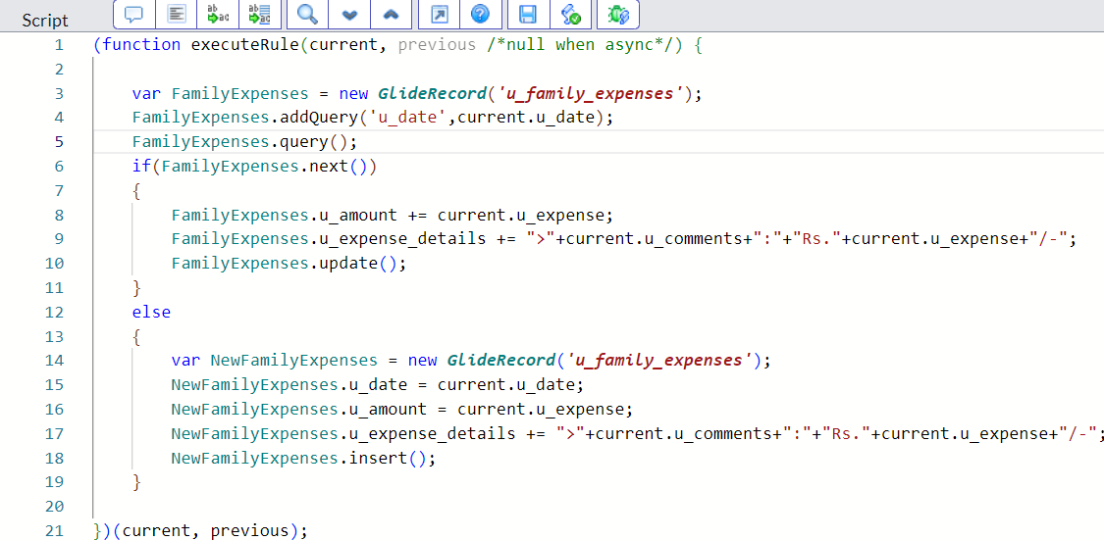

1. Go to the Header and right click there>> click on Save.

### Milestone 14 : Configure The Relationship

1. Go to All >> In the filter search for Relationships >> Open Relationships.
2. In that, open Daily Expenses Relationship.
3. For Applies to table : Select Family Expenses.
4. In Query with : write the below Query.

(function refineQuery(current, parent) {

// Add your code here, such as current.addQuery(field, value);

current.addQuery('u_date',parent.u_date);

current.query();

})(current, parent);

1. Click on Update.

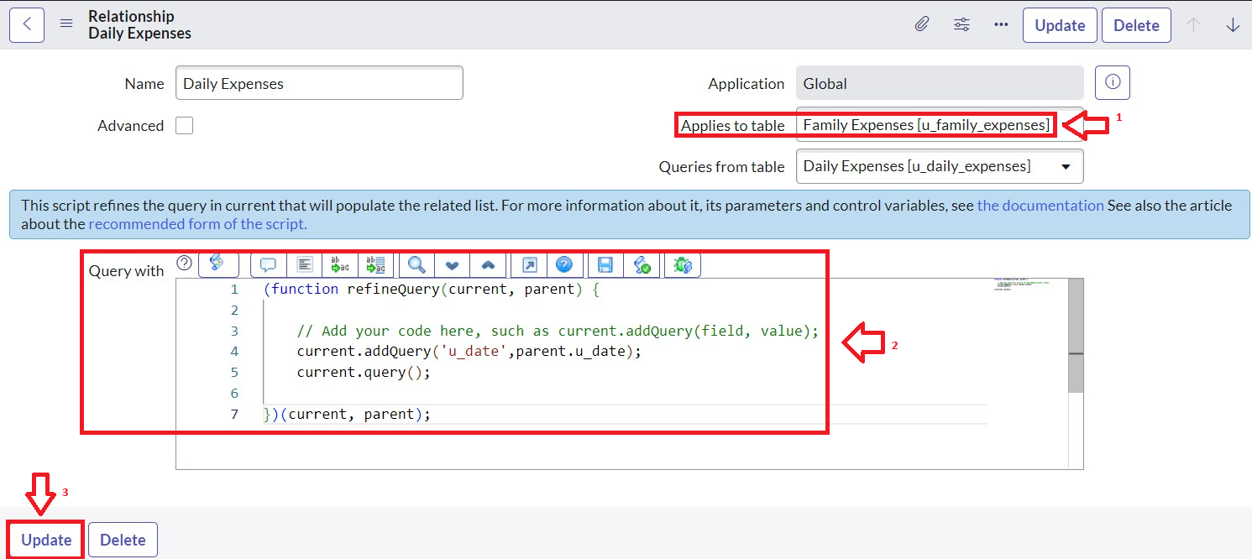

### Milestone 15 : Conclusion

Implementing a family expense calculation system in ServiceNow provides a structured and automated way to track, analyze, and manage household finances. By leveraging ServiceNow’s features such as forms, workflows, reports, and dashboards, family members can record daily expenses, categorize them (e.g., food, education, utilities, entertainment), and generate visual insights. This not only reduces manual effort but also improves accuracy and transparency in financial planning.

Overall, using ServiceNow for family expense management enhances budget control, decision-making, and savings strategies, demonstrating how enterprise platforms can be effectively customized for personal and household use.